**Accueille à Montréal**

**l’instructeur invité Sensei Don Sharp, 6e Dan**

**de la Vallée Shidokan dojo, Chilliwack, Colombie-Britannique.**

**du lundi, le 28 septembre, 2015 au dimanche le 4 octobre, 2015**

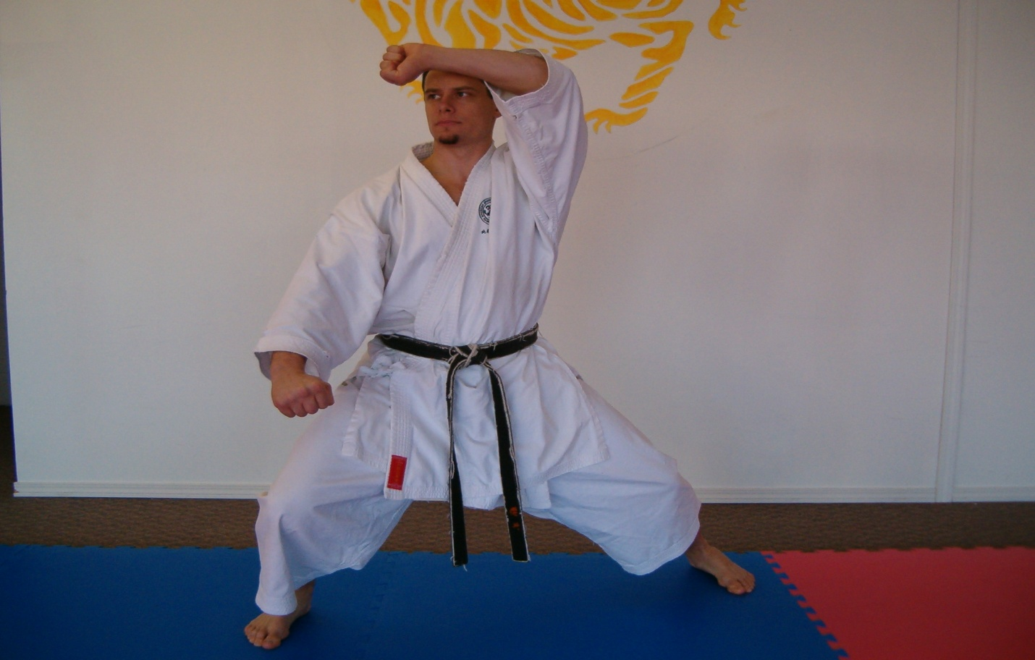

**Don Sharp 6e Dan**

le 10 septembre, 2015,

Chers karatekas,

Nous sommes fiers d'annoncer la tenue du Gasshuku JKA – de l'Est du Canada 2015, avec l’ instructeur invité JKA Sensei Don Sharp, 6e Dan, de Valley Shidokan dojo, Chilliwack, Colombie Britannique. Vous trouverez ci-joint la biographie de Sensei Don Sharp préparée par un des ses étudiants (en anglais).

L'événement se tiendra du **lundi, le 28 septembre au dimanche, le 4 octobre, 2015.**

Pendant cette période, Sensei Don Sharp **enseignera aux dojos suivants**:

Kirkland JKA, Notre-Dame du Laus JKA - Sakurai Dojo, Westmount JKA, Shidokan international - Kangeiko & l’Université de Concordia, Côte St Luc JKA, et Nuns’ Island JKA.

C’est une excellente occasion de s’entraîner avec Sensei Don Sharp, et avec les instructeurs et membres de dojos JKA.

Veuillez trouver ci-dessous le calendrier de l événement et les adresses des dojos d’accueil, ainsi que les frais de participation.

Pour toute information complémentaire, veuillez contacter les dojos dont les coordonnées sont indiquées dans le tableau ci-dessous.

Si, vous êtes **membre de l'un des dojos d’accueil**, vous devez vous inscrire à votre dojo. Si, vous **n'êtes pas membre d'un des dojos d'accueil**, vous devez vous inscrire au dojo au moment de l’entraînement.

Nous espérons vous accueillir en grand nombre ! Votre participation fera de cet événement un succès !

Les instructeurs des dojos d’acceuil.

**Calendrier**

|  |  |  |  |  |
| --- | --- | --- | --- | --- |
| **Date** | **Lieu** | **Horaire** | **Niveau**  **( Ceinture)** | **Instructeurs** |
| **lun, le 28 sept, 2015** | L’université de  Concordia Dojo  Le Gym  1515 St Catherine w  Local S2.02  Metro Guy-Concordia | 18:15 – 19:15 | Jaune - Noire  Adultes seulement | Melarie Taylor, 5e Dan  514 735 4389  melarietaylor55@gmail.com |
| **mar, le 29 sept, 2015** | Kirkland JKA  Kirkland Arena  16950 Hymus  Kirkland,  H9H 3W7 | 18:00 – 19:00  19:00 – 20:00 | Pour tous  Verte - Noire | Mark Deschatelets, 5e Dan  514 214 7180  mdeschatelets@traffictech.com  Angelo Massotti, 5e Dan  514 299 6354  [unitedbrokersqc@gmail.com](mailto:unitedbrokersqc@gmail.com) |
| **mer, le 30 sept 2015**  **mer, le 30 sept 2015** | Kangeiko dojo  Decarie Square  M Fitness  6900 Decarie  2ieme étage  Mtl. Entrée par le garage au sous-sol.  Westmount JKA  Westmount Community center  4675 St Catherine w  Westmount, H3Z 1S4 | 6:00 – 7:00  18:45 -19:45 | Noire  Adultes seulement  Pour tous | François Gelinas, 6e Dan  Melarie Taylor, 5e Dan  514 735 4389  melarietaylor55@gmail.com  Ashraf Ismail, 4e Dan  David Pinchuk, 4e Dan  Rosanna Eugeni, 3e Dan  514 941 1962  rosanna@westmountjka.com |
| **jeudi, le 1 oct, 2015** | Kirkland JKA  Kirkland arena  16950 Hymus  Kirkland, H9H 3W7 | 18:00-19:00  19:00-20:00 | Pour tous  Verte - Noire | Mark Deschatelets, 5e Dan  514 214 7180  mdeschatelets@traffictech.com  Angelo Massotti, 5e Dan  514 299 6354  [unitedbrokersqc@gmail.com](mailto:unitedbrokersqc@gmail.com) |
| **ven, le 2 oct, 2015** | Cote St Luc JKA  West End Gym  7025 Cote St Luc  Niveau sous sol | 18:00-19:00  19:00-20:00  20:00-21:00 | Jaune - Verte  Bleu - brune  Noire | Stacy Ungar, 5e Dan  514 487 7839  [Stacy.ungar@sympatico.ca](mailto:Stacy.ungar@sympatico.ca) |
| **sam, le 3 oct, 2015** | Nuns’ Island JKA  300 chemin du Golf  L’Ile des Sœurs  H9J 4C3 | 10:00-11:00  11:00-12:00 | Pour tous  Brune - Noire | Sharhokh Hoghooghi, 6e Dan  514 909 9089  [nunsisland@canadajka.ca](mailto:nunsisland@canadajka.ca) |
| **dim, le 4 oct,**  **2015** | Notre Dame du Laus JKA - Sakurai Dojo  4 rue de l église  Notre Dame du Laus, QC  J0X 2M0 | 10:30 –12 :00 | Pour tous. | Mark Deschatelets, 5e Dan  819 767 2893  mdeschatelets@traffictech.com |

**Frais de Participation**

|  |  |  |
| --- | --- | --- |
| **Cout du Camp & # de classes** | **Demi Camp Cout & # de classes** | **Cout / classe** |
| $30 Blanche / 4 classes  $50 Jaune - Orange / 6 classes  $70 Verte- Bleue / 9 classes  $80 Brune / 9 classes  $90 Noire / 10 classes | $20 Blanche / 2 classes  $30 Jaune – Orange / 3 classes  $45 Verte - Bleue / 4 classes  $45 Brune / 4 classes  $60 Noire / 6 classes | $15 Blanche  $15 Jaune - Orange  $20 Verte - Bleue  $25 Brune  $30 Noire |
|  |  |  |

**instructeurs des dojos d’accueil**

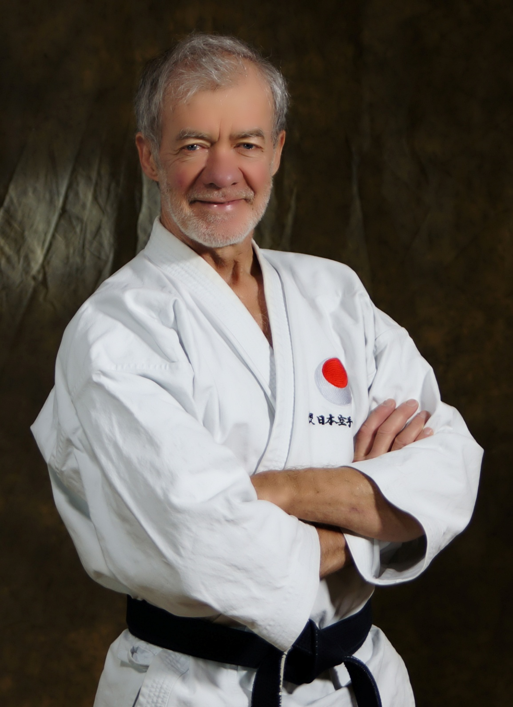

**François Gelinas 6e Dan**

**Pionnier du Karaté au Québec**

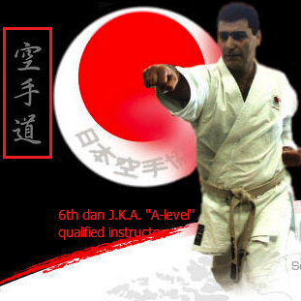

**Shahrokh Hoghooghi, 6e Dan**

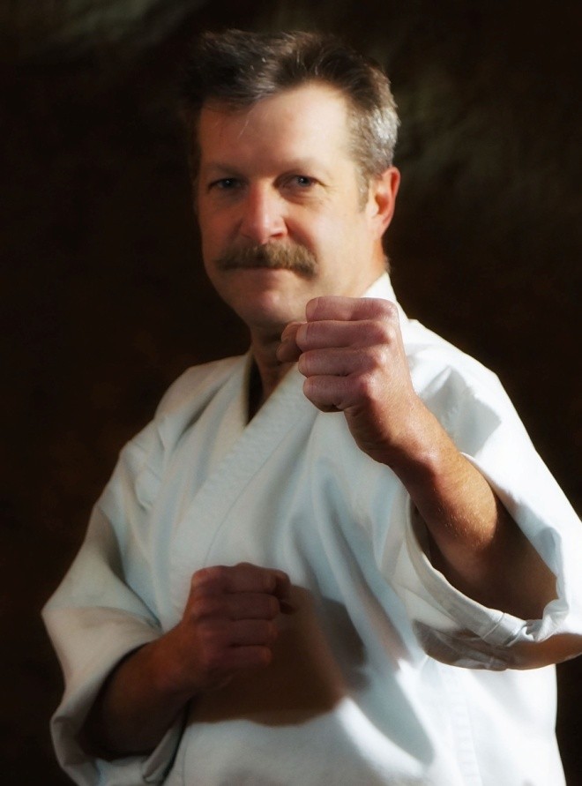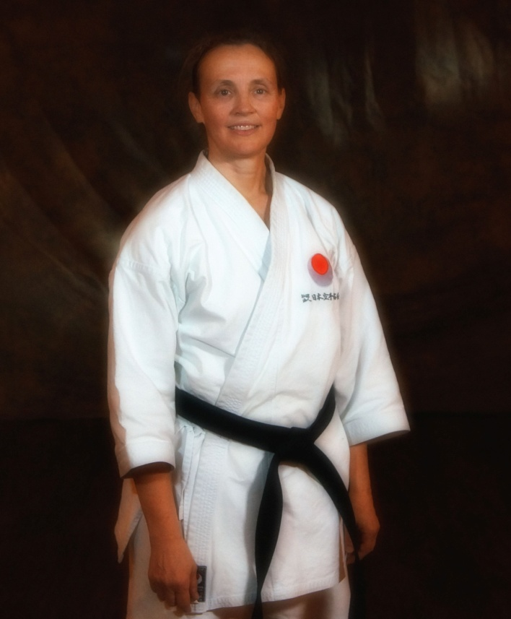

**Mark Deschatelets, 5e Dan** **Melarie Taylor, 5e Dan**

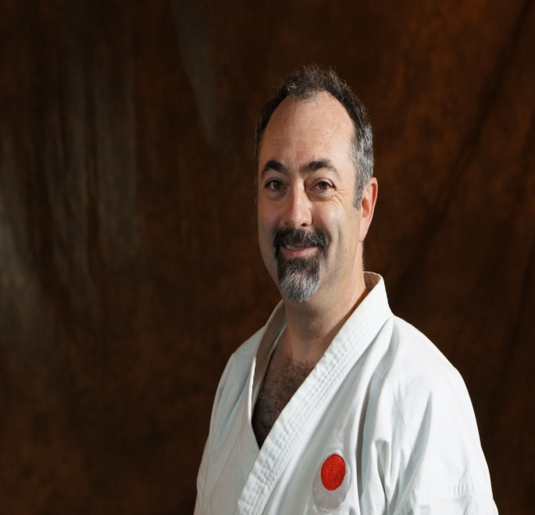

**Angelo Massotti, 5e Dan**

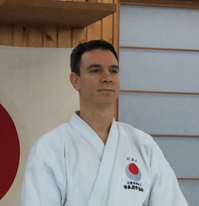

**Stacy Ungar, 5e Dan**

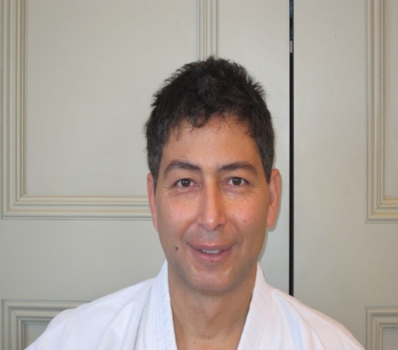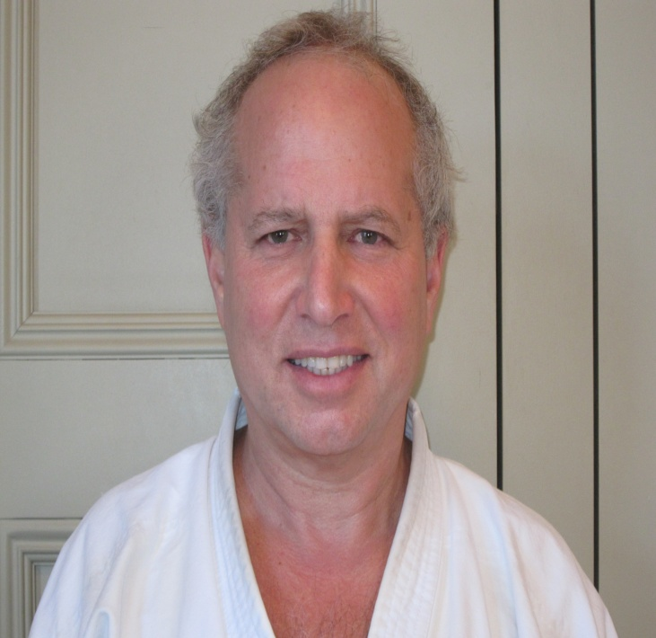

**Ashraf Ismail, 4e Dan**  **Dave Pinchuk, 4e Dan**

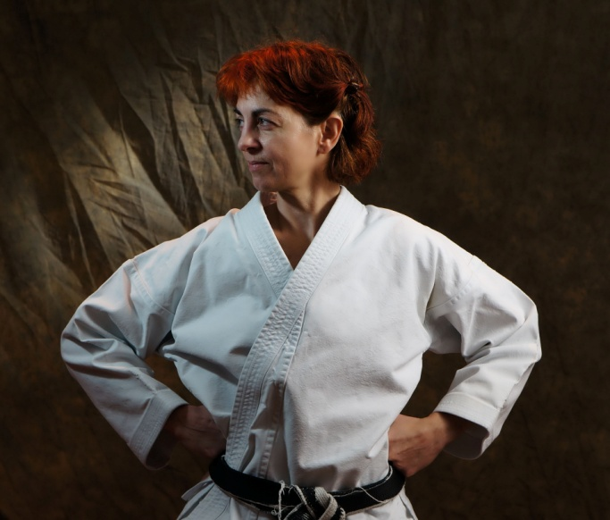

**Rosanna Eugeni, 3e Dan**

**My Instructor, Don Sharp**

**Many of us know how lucky we are to be training with Sensei Don sharp, because of his great teaching ability, his character, his enthusiasm and tremendous expertise of our art…. But I think many of our members have no clue how truly accomplished our instructor is. Don Sharp being so modest we just don’t often hear of his own accomplishments. So I am writing this biography in hopes that our members will know a little more of our instructor and really get a feel for how fortunate we are.**

**Don Sharp started training in JUDO at the age of 9. He had already fallen in love with the martial arts and that was his option at the time. He trained very hard and even at that age was noticed by his Sensei’s , Ken Earhart and Dave Jones. Unfortunately the club folded after Don had trained there for a couple of years and had gotten his 3rd Kyu. He continued training under Ken Earhart and still keeps a relationship with Mr. Earhart to this day, over 30 years later. Don saw a Karate club training at the local “Y” and was instantly captured!!! He started right way, under his first Sensei Rob Gale. He trained hard and got to 4th kyu very quickly for a young boy, and then he met Sakurai Sensei!!! Don still talks about that first meeting and training with Sakurai Sensei as a remarkable time of his life and eye opener on what martial arts had to offer. Not just how to kick and punch, but a way of life, a balance of physical, mental, technical and even spiritual way of developing ones growth.**

**He continued to train under Rob Gale until Sensei Rob Gale turned to Don and asked him if he would take over the Dojo! He was only 18 at the time and had just passed his Shodan a couple of months before under Nishiyama Sensei and Sakurai Sensei. He, of course accepted and he then became the chief instructor of the Chilliwack club. He knew he needed to continue his training as much as he had always even though he was now responsible for teaching the members of the club, so he would drive to Abbotsford to train with Rob Sidoli and all the way to Vancouver to train with Sakurai Sensei. He would always say, ”one who wishes to be a worthy teacher must always continue to be a student. I don’t want to be one of those Sensei’s with my fingers in my belt pointing to my students to do this better or that faster, without making a move myself”. His Dojo quickly gained respect and notoriety with Don going on to Nidan at only 20 years of age, and himself and many of his Dojo members already showing signs of success at tournaments. He was one of the founding fathers of NASKA as a brown belt at 16 year old, and throughout his career has always been a great advocate of Sakurai Sensei’s and of NASKA. He is considered by many to be the most well rounded Karate instructor in Canada. As a competitor he is considered one of the most successful Canadian athletes of all time in Karate.**

**His accolades**

**Competition-**

**Provincial competition**

**Over 45 medals in provincial competition, including 29 gold medals**

**A total of approx. 200 medals from local, Provincial, National and International tournaments. Awarded provincial athlete of the year 4 times!**

**National Competition**

**11 times national Kumite champion, 5 NKA titles and 6 JKA titles.**

**5 times medallist in national level kata competition**

**\*Awarded Canadian athlete of the year twice!**

**Highlights of national level**

**1995 Nationals- Gold medal open weight kumite, Silver Heavy weight kumite, Gold medal team kumite, ATHLETE OF THE YEAR AWARD, NATIONAL, and SPIRIT OF KARATE-DO AWARD.**

**1997 Nationals- Heavy weight Kumite Gold medal, open weight bronze, Kata silver, and team kumite silver ATHLETE OF THE YEAR AWARD NATIONAL**

**1999 Nationals- Heavy weight kumite Gold, Kata silver, team kumite Bronze, (open weight injury, DNF)**

**1996- JKA nationals Gold kumite, Silver Kata, bronze team kata, and Gold team kumite.**

**International competition**

**1996- JKA WORLD CHAMPION, Gold medallist kumite, Osaka Japan**

**1995- WKF silver medallist Pan Am Championships, Lima Peru**

**1999- Pan Am Games- fourth place**

**5 other top 5, or better finishes in world level events of both WKF and JKA events**

**Coaching**

**Captain of 2 WKF world cup teams, and 3 World JKA Shoto Cup teams**

**B.C. Team Coach 3 times.**

**World Shoto Cup team assistant coach twice**

**Other accolades**

**Don Sharp has received a ‘LETTER OF ACCOMPLISHMENT “, from the Prime Minister of Canada, Jean Chretien, and 3 letters from provincial premiers**

**He received the B.C. premieres Award of excellence in athletics, and was in the B.C sports hall of fame for the year of 2000.**

**He is presently on the board of JKA-SKD, on the technical committee of JKA SKD Canada, and Technical chairman of JKA-BC**

**Don Sharp has gotten his JKA instructors course level “A” in international refereeing, "A" instructing and level “B” examining. As well, he has his special JKA rights for Nidan exams as well as D level instructors course exams.**

**He passed his Rokudan (6th degree black belt) in October of 2011. He did this at the World JKA headquarters (honbu Dojo) in Tokyo Japan. (A very rare occurrence for a foreigner even being allowed to grade let alone passing at the prestigious headquarters grading. He was graded under the most senior ranked instructors in the world, including the JKA World chief instructor, Ueki Shunzeki Shihan**

**Received 3 National Athlete of the year awards and 4 Provincial awards.**